**HIRING PROCESS ANALYTICS**

**Project Description**

For instance, I work as a data analyst for a large corporation like Google. It is my responsibility to examine and extrapolate useful information from the company's employment process data. Any business must do the essential task of hiring new employees, and the hiring department can get important insights by tracking patterns in things like the frequency of interviews, rejections, job categories, and openings.

I'll be given a dataset as a data analyst with records of prior employees. In order to help the business improve its hiring procedure, it is my responsibility to examine this data and provide answers to specific inquiries.

**Approach**

I started by using the Excel Data Analysis Tool Pack to perform an exploratory data analysis. On the column for salaries offered and calculated descriptive statistics. Utilize the quartile tool in Excel to identify missing numbers and outliers. Additional insights were obtained using Excel formulas and graphs after the outliers had been removed.

**Tech-Stack Used**



Microsoft® Excel® 2010

This tool is intended to visualize the results and have a better understanding of the data collection.



Microsoft® Word® 2010

This tool is to create a report (PDF) that will be delivered to the leadership team.

**Insights**

1. **Hiring Analysis: Here my task is to identify how many “Males” and “Females” are hired into a company.**

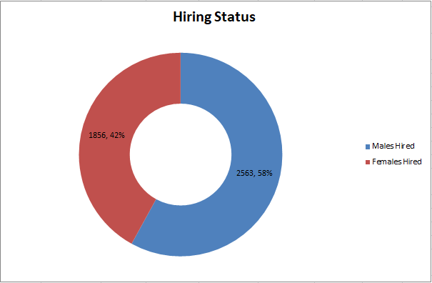

There are total of **2563** Males and **1856** Females are hired into a company, which is around 58 and 42 percent respectively.

So the total employees hired by the company were 4419.

1. **Salary Analysis: In this I need to perform the average salary using excel functions.**

**Accordingly, the average wage is determined from the given dataset using the "=SUM(G:G)/COUNT(A:A)" or "=AVERAGE(G:G)" functions.**

**So the average salary offered in this company was “49976.0559”.**

1. **Salary Distribution: Here my task is to identify the average salary distributed into the each class interval.**

So by using the following formula I was identified the average salary distributed into each department.

**“=AVERAGEIF(E:E,"Department_name",G:G)”** according to the given dataset.

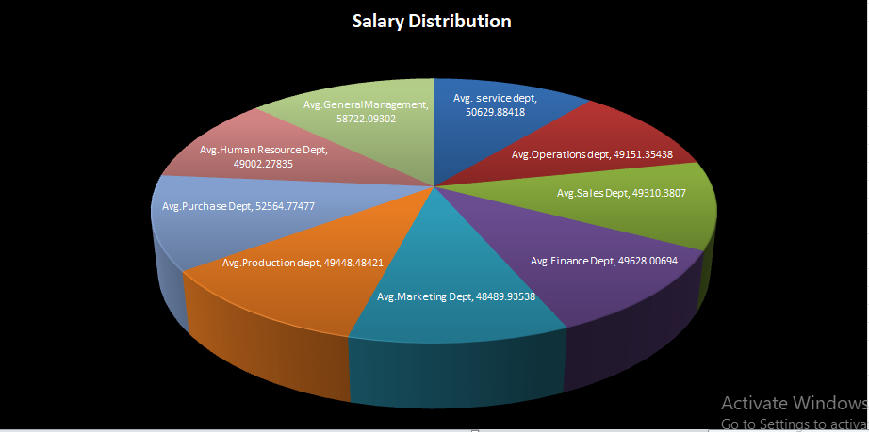

1. **Departmental Analysis: Here by using a bar graph, I demonstrate** the proportion of people working in different departments.

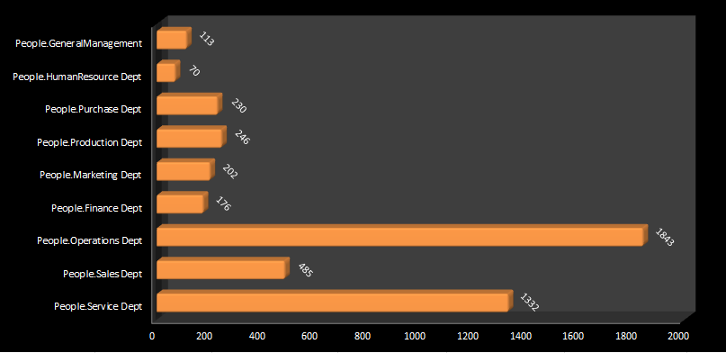

The more number of people (1843) are working in **“Operations Department”** followed by Service and Sales departments and least number of employees worked in Human Resource Department.

1. **Position Tier Analysis: Using a bar graph, I** represented the different position tiers within the company.

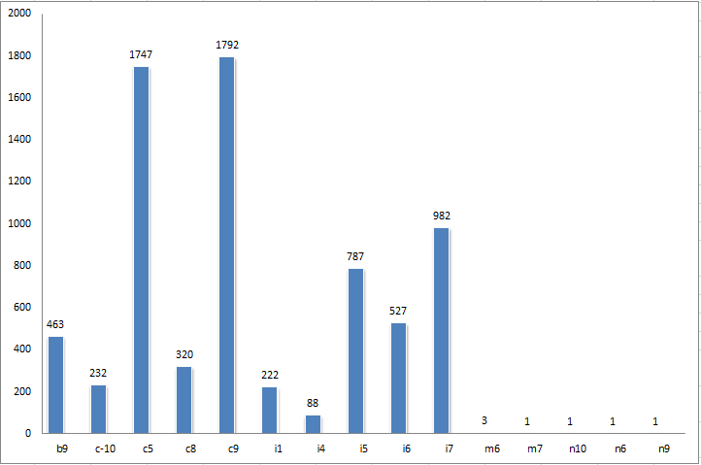

The maximum number of employees is observed in “c9” Tier and minimum are observed in m7, n10, n6 and n9 respectively.

**Conclusions**

* I now have a better understanding of the idea behind exploratory data analysis thanks to this project.
* My understanding of the analyses needed in the company's hiring process has improved as a result of this endeavor.
* My proficiency in Excel has increased because to this endeavor.

**Excel Worksheet Drive Link:** <https://docs.google.com/spreadsheets/d/1cFZRFMuiFBZDk3WYeQx-IApAGeZFxtq2/edit?usp=sharing&ouid=103408134219481963473&rtpof=true&sd=true>